**Python project:**

Will allow us to predict the prices, allowing the sellers to classify the device's prices according to their characteristics.

**1- Run RESTful API** (Python Endpoints)

Will take the specs for any device, and send it to your ML model, then return the predicted price.

In CMD, navigate the folder where the python app is exist:

***- Simply:***

- Open CMD

- Write cd

- Paste the path of the folder

Like this:

cd C:\Users\Naim Rihan\Desktop\Price APP

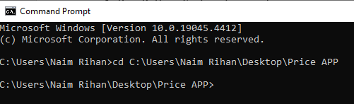

Then:

Start the python app using:

- Python [name of the app].py and press Enter

Like this: Python price_app.py

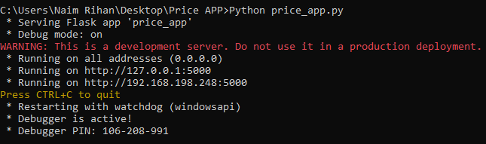

- Here we can try the API using Postman:

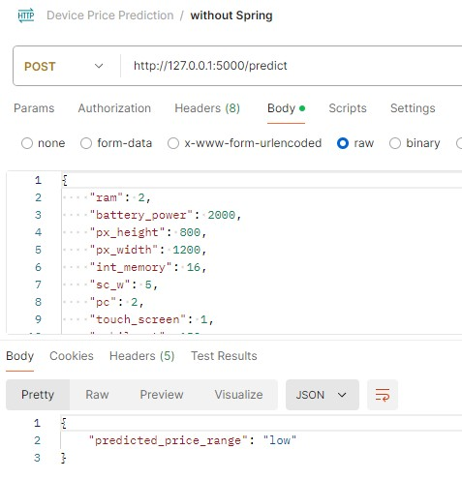

----------------------------------------------

**SpringBoot project:**

Will contain a simple entity, and a few endpoints, to call the service from the Python project for a bunch of test cases, and store them.

**2- Run Spring Boot System:**

In the same way navigate the folder where Spring Boot project is and copy it

- Open another window in cmd:

C:\Users\Naim Rihan>cd C:\Users\Naim Rihan\Desktop\demo

- Then run Spring using this command: mvnw.cmd spring-boot:run

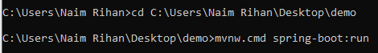

Then you will see like this:

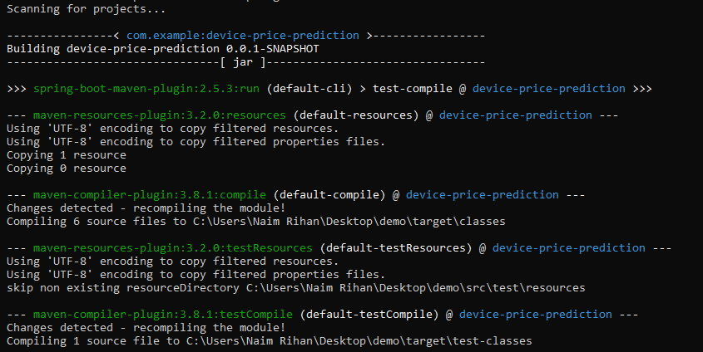

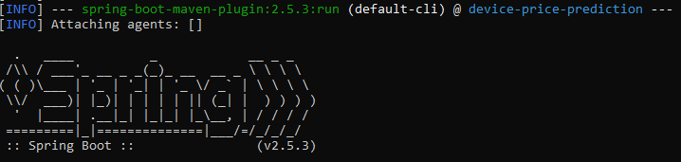

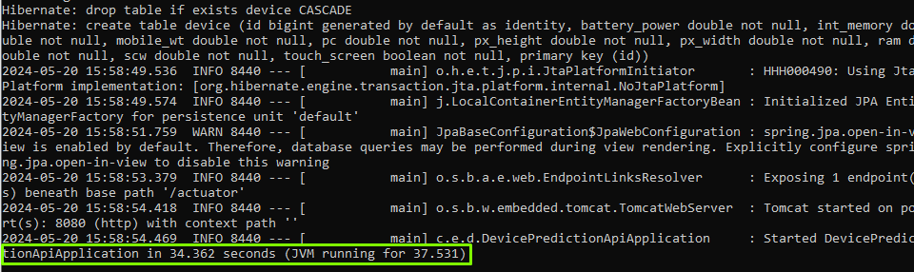

That indicates that the project is running now!

Now we will Open Postman to try the system:

**1- Add a new device:**

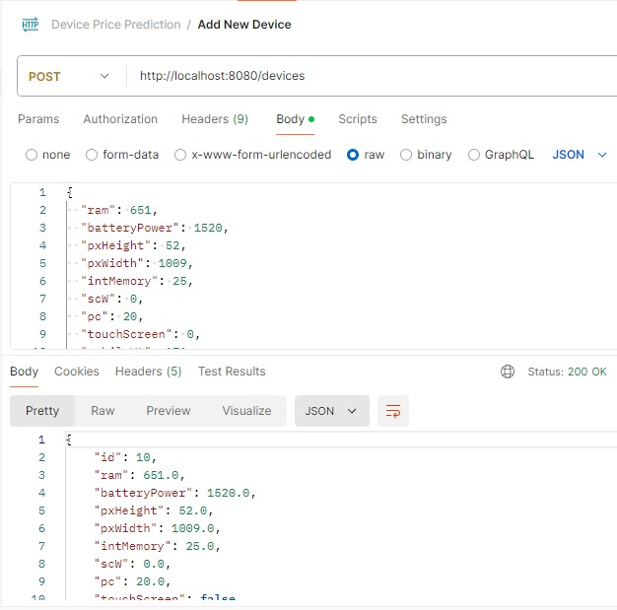

**2- Retrieve details of a specific device by ID:**

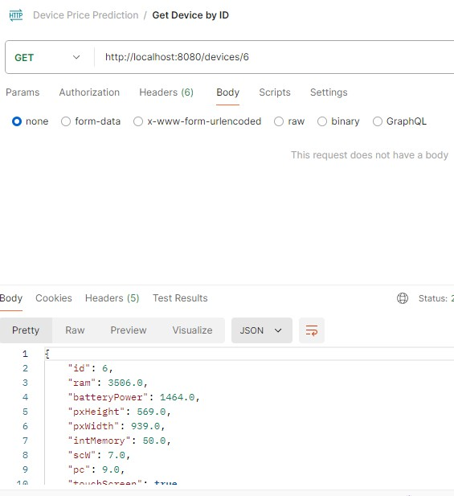

**3- Retrieve a list of all devices:**

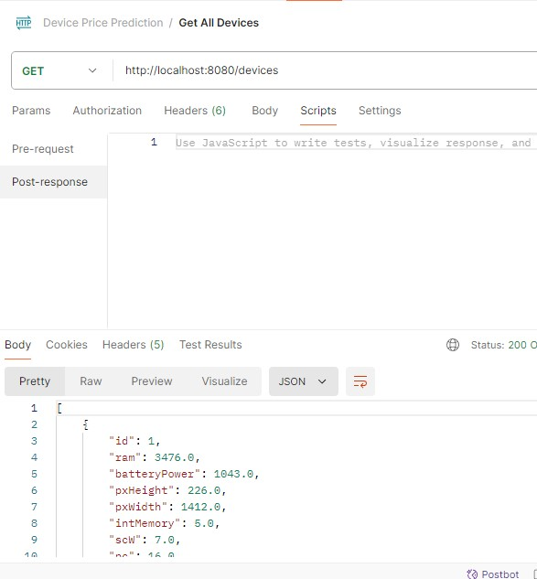

**4- Predict the price:**

